Problem Statement: You work for XYZ Corporation that uses on-premises solutions and some limited number of systems. With the increase in requests in its application, the load has increased. So, to handle the load, the company needs to buy more systems almost on a regular basis. Realizing the need to cut down the expenses on systems, the company has decided to move its infrastructure onto AWS. You are asked to:

1. Manage the scaling requirements of the company by:

• Deploying multiple compute resources on the cloud as soon as the load increases and the CPU utilization exceeds 80%

• Removing the resources when the CPU utilization goes under 60%

* 1. Create a Launch Template.

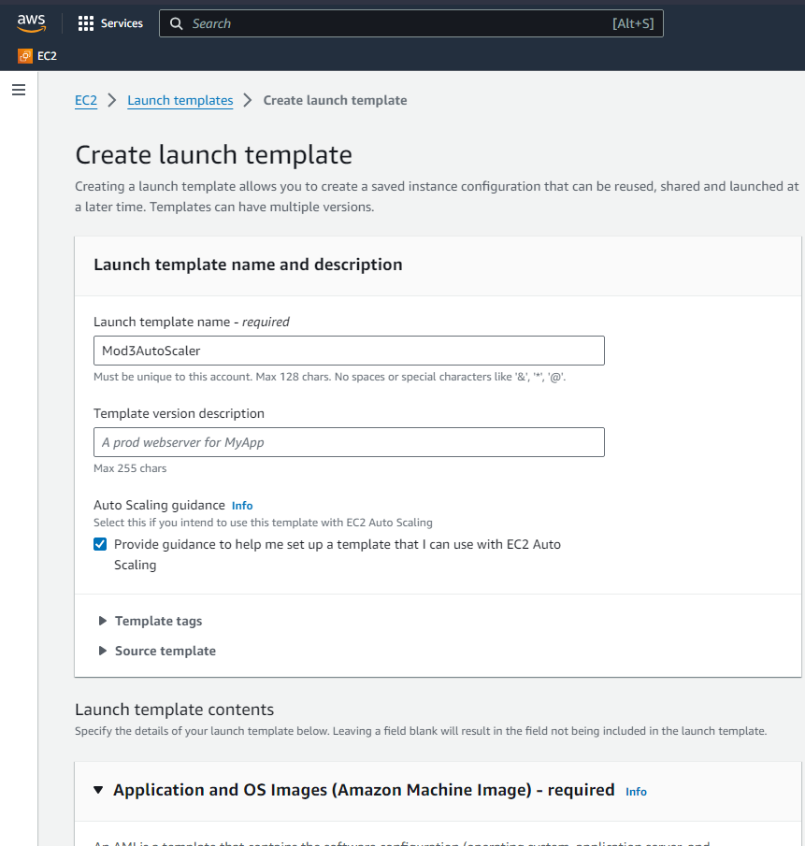

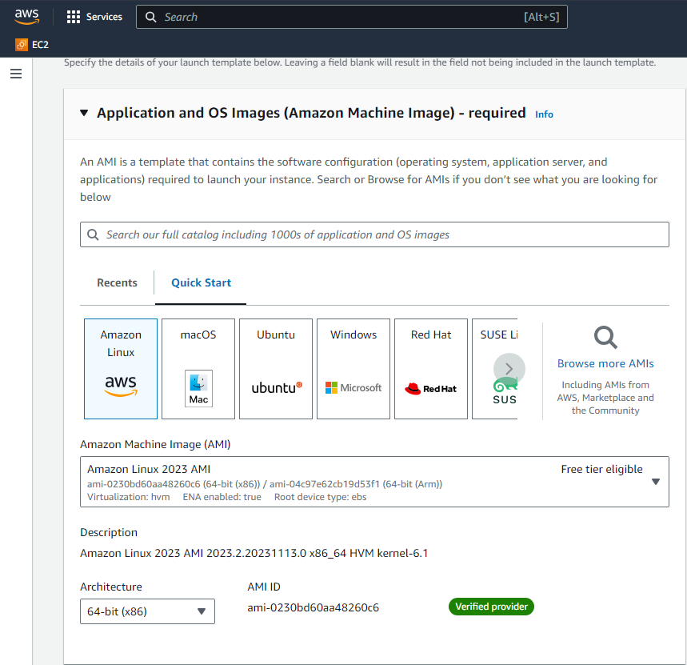

* 1. Create a Auto Scaling Group. Choose Default Options.

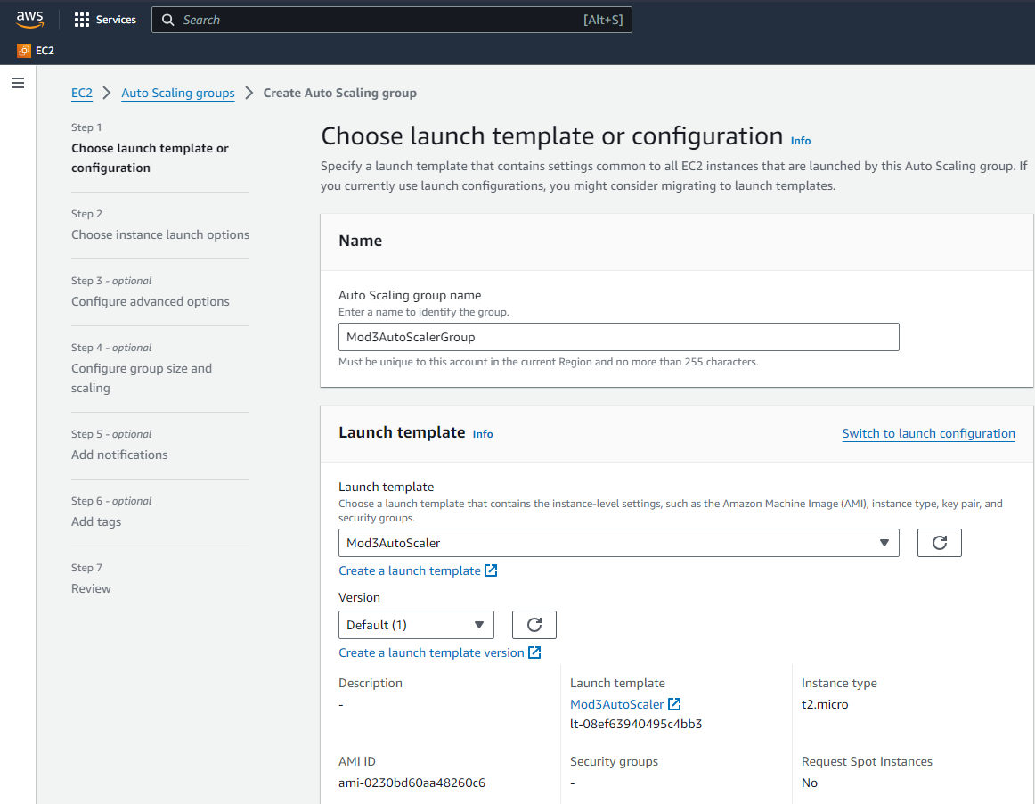

* 1. Configure the Auto Scaling Group to Scale Out when CPU Util hits 80%. Create an Alarm first, and then configure the Auto Scaling Group to Scale Out.

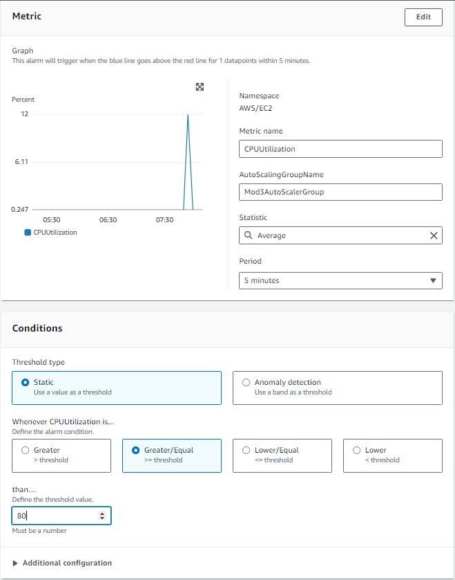

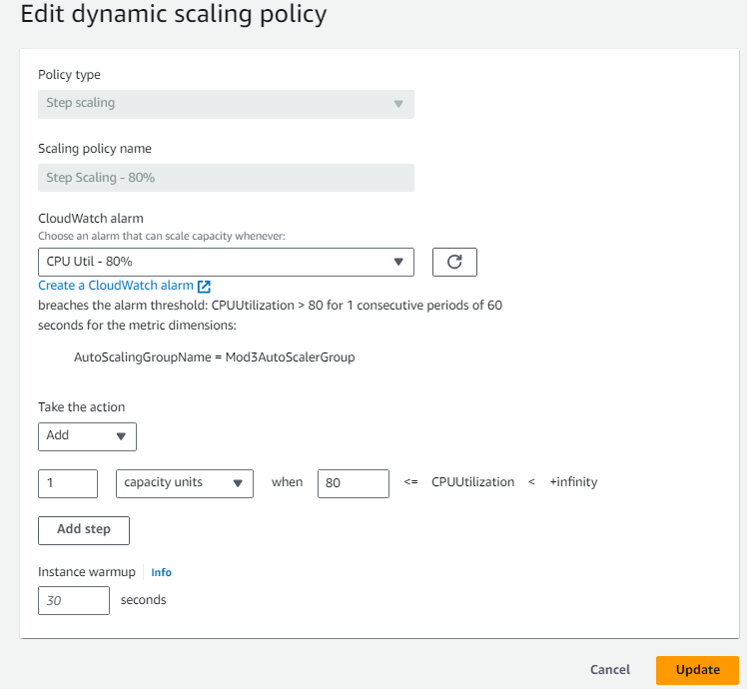

* 1. Create a Rule for Scale In when CPU Util is below 60%

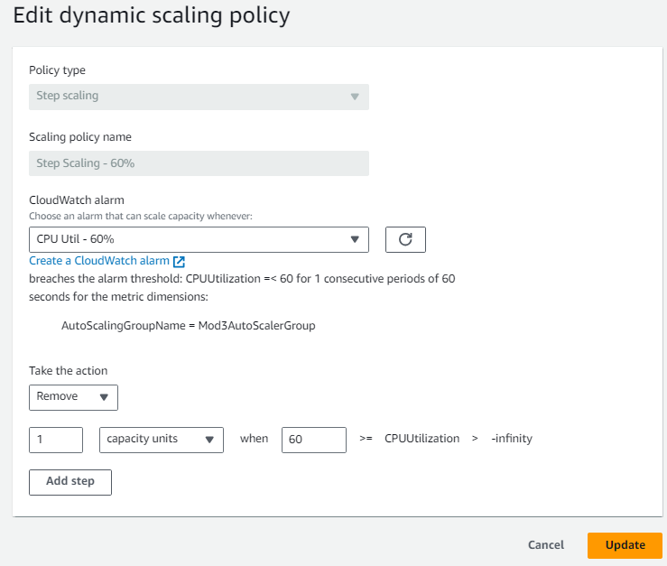

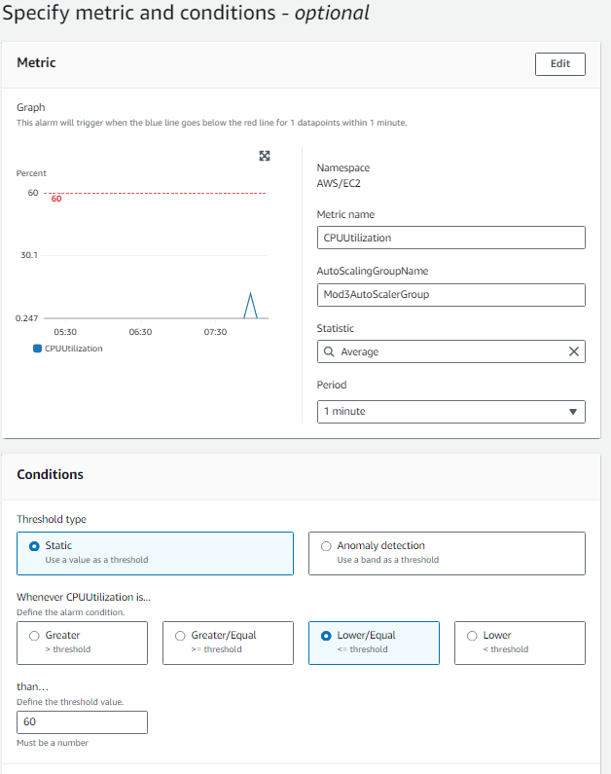

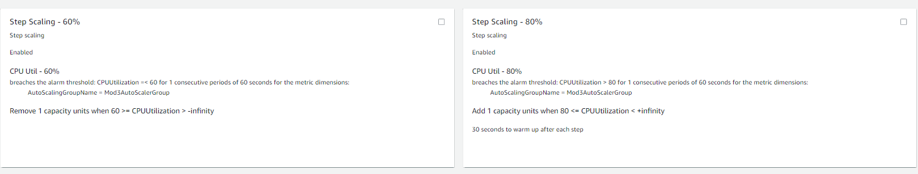

* 1. Executed Scale Out Rule for Demo, Scale In follows as per Alarm since the CPU Util was under 60%

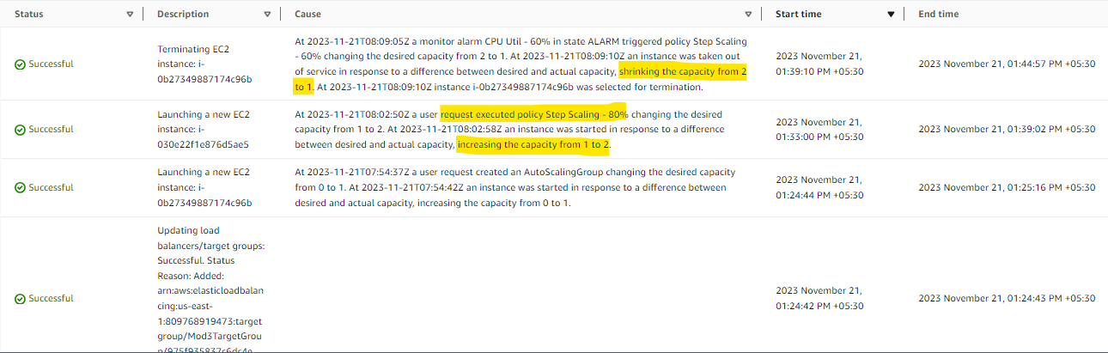

1. Create an Application Load balancer to distribute the load between compute resources

• In your two target groups, make one for Blue deployment and the other for Green

• Use weighted routing to route 70% of the traffic to the Blue target group and 30% of the traffic to the Green target group

* 1. Create a Target Group and Load Balancer.

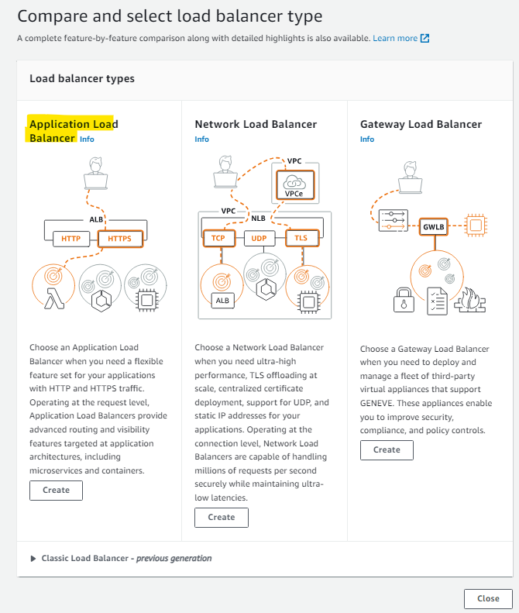

* 1. Create 2 Target Group – 1 for Blue Deployment Instance and another for Green Deployment Instance.

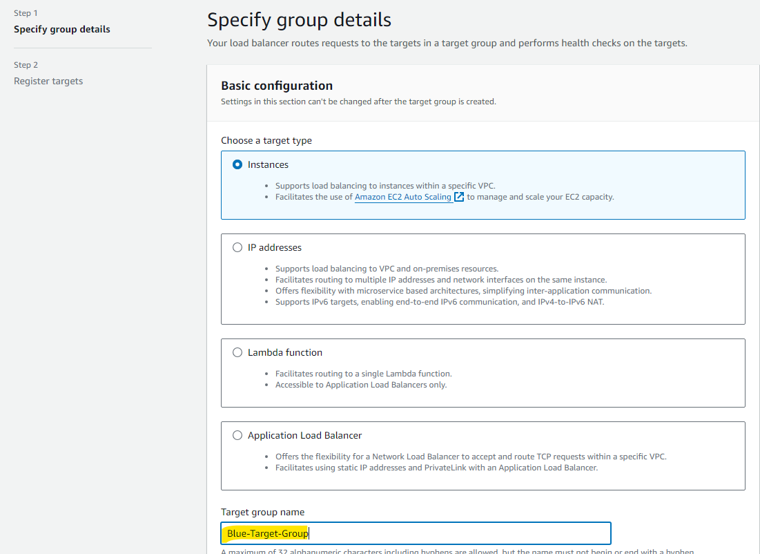

* 1. Register the Blue Deployment Instance to Blue Target Group vice versa for Green Deployment.

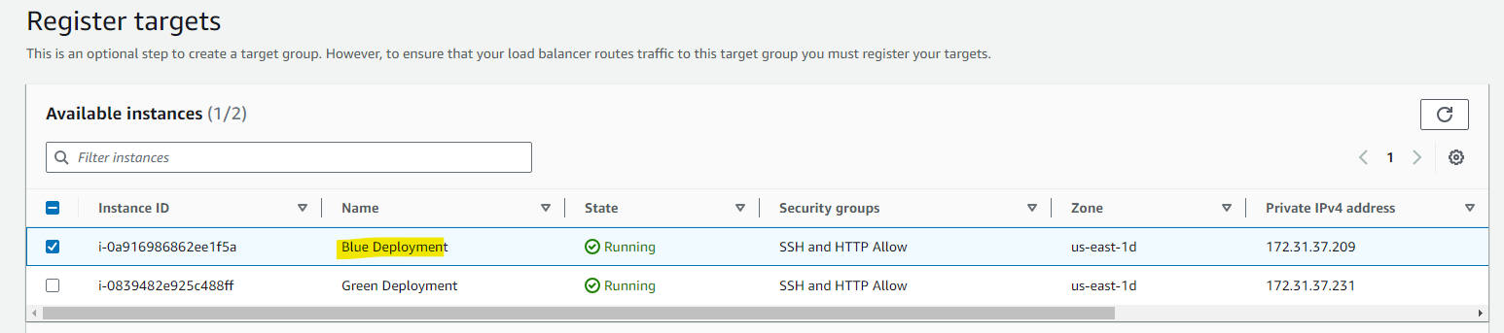

* 1. Add the Listener and Assign Weight.

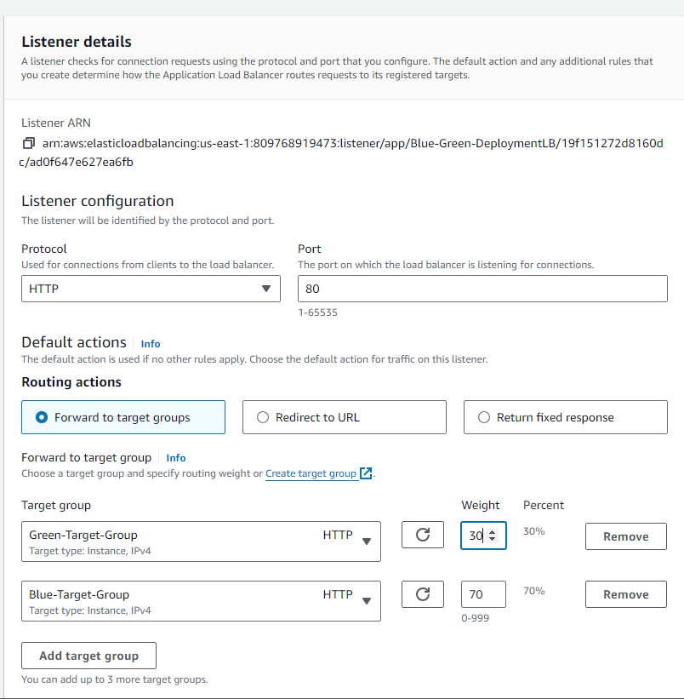

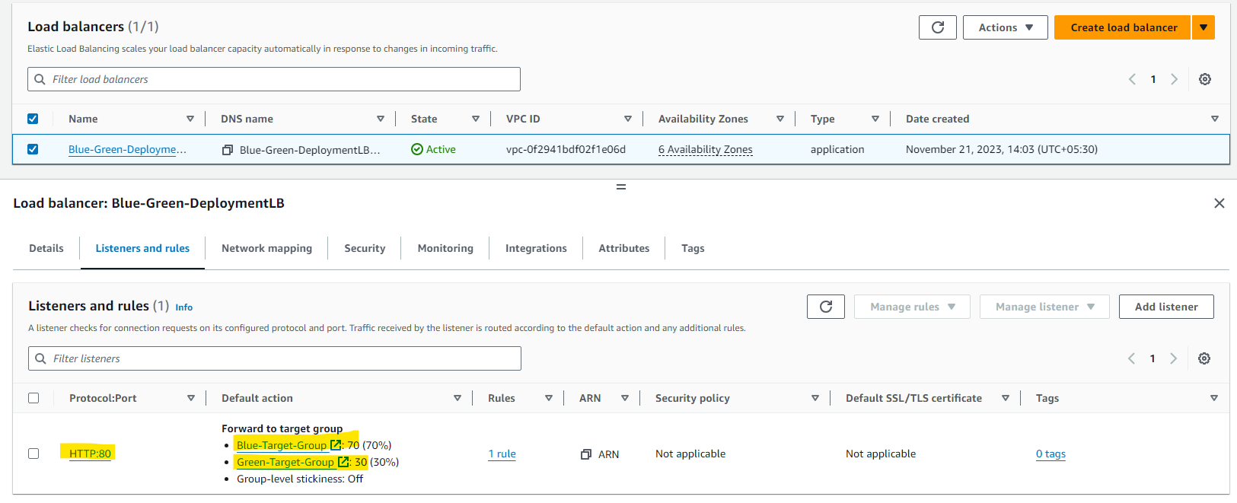

* 1. Blue-Green Deployment are working as expected via LB.

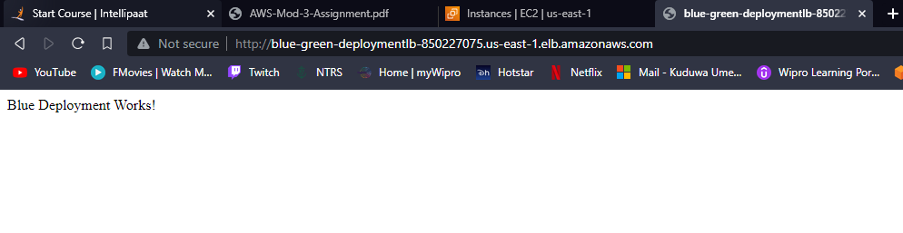

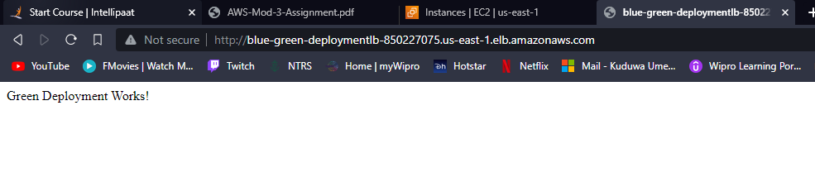

3. Route the traffic to the company’s domain (Not able to get a free domain, hence skipping this point)